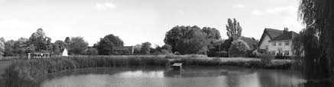

Thrandeston Annual Parish Meeting

**Minutes of the Meeting on Wednesday 9th May 2018.**

Present: Councillors A Colchester, S Colchester, Hawes, Murton, Burn and Fleming.

Six members of the public.

1. Apologies for absence

* Councillor Cotter.

1. Chairman’s opening remarks.

* The Chairman welcomed everyone to the meeting.

1. Acceptance of Minutes of 2017 Annual Parish Meeting (2nd May 2017)

* The minutes were accepted as a true record.

1. Matters arising from Minutes of 2017 Annual Parish Meeting

* None.

1. Reports

To receive reports from:

* Thrandeston Parish Council

Goff Hawes – Chairman.

Quite an uneventful year, with only a few issues to be dealt with.

One of the large chestnut trees, in front of Chestnut Farm, fell across the road during high winds. With a teleporter and help from the Murton family It was quickly cleared off the road and subsequently removed.

We had advice from a tree surgeon, who Informed us that the problem was caused by a very large bracket fungus. We asked him to Inspect the remaining trees and he recommended some reduction of the canopy of the remaining trees. This work was carried out.

We experienced the usual problems with the hay cutting on the Green, due to the enforced late cutting, Imposed by Natural England and particularly wet weather. Nothing unusual there!

An area of the Marsh has become infested with Inappropriate vegetation, making it undesirable to the grazing cattle, which has resulted in a considerable quantity of sapling growth. With the agreement of Natural England, this area has been topped to restore more grass.

The ‘foot drain' which was dug to allow more water to enter the scrape, for the benefit of wildfowl, has, predictably, been poached by the cattle. Natural England has advised against the re-digging of the drain.

A planning application was received for conversion of buildings, at Marsh Farm, for use as a wedding venue. After much discussion the application was approved **by** the parish council

Despite continual complaints to the highways department regarding the potholes in the village roads, we have achieved only limited success, with some of the holes being filled In. We continue to pester the highways department on a regular bas is. ft may be possible that If local residents also complained, it might help.

The annual 1mer pick took place on 14th April with a fairly average amount being collected. Thanks

to the usual bunch of volunteers.

Due to the snow earlier in the year and the heavy rain, the scrape, on the Marsh, is full to overflowing and being enjoyed by a wide variety of wildfowl species. Have we finally got something right?

The planning application for Marsh Farm has been approved by Mid Suffolk District Council.

* Mid Suffolk District Council – Councillor David Burn

I’m very aware that the workings of local government can be very uninteresting to the residents who receive its services. Deciding what to include in this annual report is therefore quite difficult. I’m not going to attempt a summary of all that has taken place at the council in this very busy year but here are a few snippets that I am presenting simply as…

HAPPENINGS AND OTHER ITEMS OF POSSIBLE INTEREST:

* Mid Suffolk District Council completed its **move from the Needham Market HQ to Endeavour House** in Ipswich, as did Babergh DC from theirs in Hadleigh. Endeavour House is also the home of Suffolk County Council and the Clinical Commissioning Groups.
  + Nearly all MSDC’s furniture was surplus to requirements in the new home and much of it was donated to local charities and community groups
  + Pretty much everything else was moved to Ipswich, from the entire IT system down to staplers and stationery.
  + To save space, some 1.2 million documents were scanned.
  + I would guess that about 60% of staff now work from Endeavour House; the rest are usually out on site-related work or work from home. Everyone is assessed on performance, which is not dependent on when and where they do the work.
  + We have established a new Customer Access Point in Stowmarket for those few occasions when face-to-face contact is needed.
  + A new website has been launched, which contains more information than the old one and is easier to navigate. For efficiency – and thereby to save money – we are encouraging all our residents to use the website as the primary means of contact with the council.
  + When a phone conversation is necessary there is now a single number to call.
* The Boundary Commission for England is **reviewing the ward boundaries in the district** to achieve two objectives:
  + Reduce the number of councillors from 40 to 34.
  + Equalise the number of electors in each ward as far as possible.
  + Locally this is likely to add three new parishes, namely Braiseworth, Stoke Ash and Thwaite, to the existing five parishes in Palgrave Ward.
  + The new boundaries will come into effect from May next year.
* Recent publicity on **‘One Council?’**: Remember the referendum in 2011 when Mid Suffolk residents voted to merge with our neighbour to the south, Babergh DC, but theirs voted against? When the votes were put together theirs narrowly won the day.
  + The merger therefore didn’t go ahead but integration of the two work forces did and we have been functioning more efficiently and at less cost as a result.
  + Over the years Babergh and Mid Suffolk have operated with increasing alignment.
  + We have drifted closer together to a point where it seemed logical to consider dissolving the two councils and re-forming as one.
  + This is what Forest Heath and St Edmundsbury to the west of us and Waveney and Suffolk Coastal to the east of us have already done (or are in the process of so doing).
  + But recently the Leader of Suffolk County Council has reopened the exploration of the Unitary Council idea for the area, combining the functions currently managed separately: the county council is responsible, for example, for education, social care provision and waste disposal in Mid Suffolk, whereas the district council handles, amongst others, licensing, waste collection and environmental health.
  + Under the unitary system all the services required in a given area would be provided by a single authority
  + The area covered by a unitary authority need not be the whole county.
  + Until this unitary suggestion has been fully explored, Babergh and Mid Suffolk have put on hold the idea of becoming one council.
* Throughout the year our strategic planning team has been working on a new **Joint Local Plan**:
  + The Local Plan is the document containing the policies against which all planning applications are assessed and decided. This new Plan will be applicable in both Mid Suffolk and Babergh districts.
  + It will replace our 1998 Local Plan and our 2008 Core Strategy (reviewed in 2012).
  + Already there has been one public consultation and there will be another in the autumn before the Plan is submitted for examination.
  + The new complement of development site allocations that will form part of the Plan will enable the recovery of our much talked about 5-year land supply.
* Elsewhere on the Planning front:
  + Introduced f**ee structure for pre-application advice**, which has so far yielded £88,000 income.
  + Introduced the **Community Infrastructure Levy (CIL)**, which is paid on residential developments by the developer, except on strategic sites. It is an obligatory payment, which is used to mitigate the impact of the development on infrastructure such as schooling and local roads.
  + **Neighbourhood Plans** were introduced in 2011 as part of the Localism Act. They sit on top of the Local Plan and allow a parish/town council to devise a set of policies on development that add detail those in the Local Plan and have the same statutory weight.
  + So far only Mendlesham has taken its NP through to adoption but there are 16 others in various stages of preparation. Stradbroke’s will be the next to be adopted and Laxfield and Fressingfield are the latest ones to embark on the journey.
  + Most notable, of course, is the Diss and District Neighbourhood Plan, a venture started las August involving seven parishes, three of which – Palgrave being one – are on the Suffolk side of the boundary. We believe this is the first NP to be cross-county.

SIGNIFICANT LOCAL PLANNING APPLICATIONS:

* **Cranswick Chicken** – £50 million investment in a state-of-the-art processing factory on Eye Airfield, representing a relocation of their existing factory at Weybread. 750 jobs. Permission granted
* **Andrew West** – eight 91x23 -metre broiler rearing sheds with a capacity of 350,000 birds at Brome on land south of Church Farm, accessed via Nicks Lane. Permission granted recently.
* **BP** – Filling Station and associated convenience store with McDonald’s drive-thru and restaurant in the parish of Stuston at what is known as the Scole roundabout. Not yet determined but is provisionally scheduled to be decided by the planning committee on 6 June 2018.
* **Progress Power/Drax** – gas-fired power station at Eye Airfield and associated substation in Yaxley; this was substantially approved in August 2015. A lot of preliminary work has been carried out this year, including archaeological investigations at both the airfield and Yaxley sites. Also hedgerow reduction and scrub clearance where the temporary junction with the A140 for substation construction traffic will be. Construction work proper will begin when the company succeeds in getting a contract to supply electricity at the annual capacity market auction, held in December. They have failed to gain a contract at the last three auctions but if successful next December, construction work is likely to begin early in the new year.
* **Mr & Mrs Paul Yaxley** – change of use to wedding venue at Marsh Farm, Thrandeston. Permission was granted on 25 April 2018.
* Suffolk County Council – Councillor Jessica Fleming

Councillor Jessica Fleming, Hartismere Division, Suffolk

[Jessica.fleming@suffolk.gov.uk](mailto:Jessica.fleming@suffolk.gov.uk) Tel: 07714-597980 Twitter: @jesstfleming

**State of the County** – Districts and Boroughs in Suffolk have taken steps to redefine themselves and merge (to form the East and West ‘super-districts’) or move, the County Council is working with its partners to streamline functions and manage public funds efficiently. The County Council is considering a review of unitary government possibilities with some or all of its partner authorities.

The Council has initiated several large projects over the past year with help from Government funding, including The Orwell River Crossings in Ipswich (below); the Lowestoft Third River Crossing; planning approval for The Hold records repository in Ipswich; upgrades(2 new roundabouts) to the A140 near Eye; and potentially A12 upgrades near Fornham and Stratford St Andrew. The A14 is seen as a growth corridor for both housing and commercial/ industrial development.

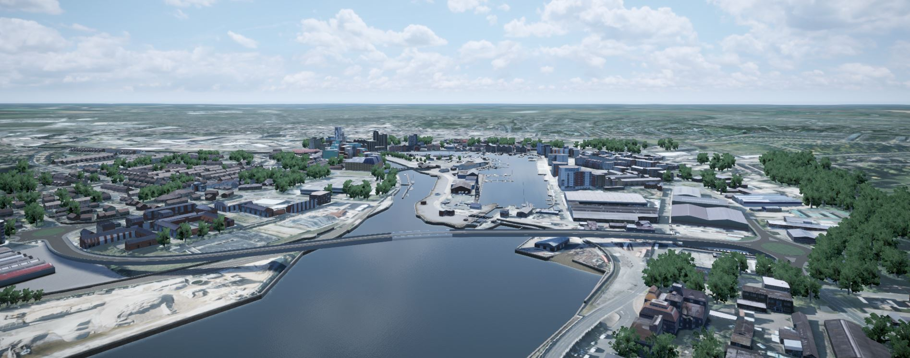

**Highways** - Suffolk Highways has established its regional customer service centres at Rougham, Halesworth and Ipswich and the reporting system is now widely used for road and drainage issues. More money has been allocated to pothole repair during 2018 given the hard winter and large number of potholes and defects that need attention.

As a reminder:

Report a defect/ pothole <https://highwaysreporting.suffolk.gov.uk/>

To check on area roadworks - <https://roadworks.org/>

**Planning** – Suffolk County Council is statutory consultee on highways, flooding, education, and natural and historic environment, it also maintains traffic data and models flow and congestion. SCC continues to work with applicants and others to represent Suffolk’s interests on major projects, such as Sizewell C, the Eye Airfield Gas Fired Power Plant (likely to go ahead in 2019 despite failing to obtain a contract in February), and Scottish Renewables’ offshore wind farms (see below):

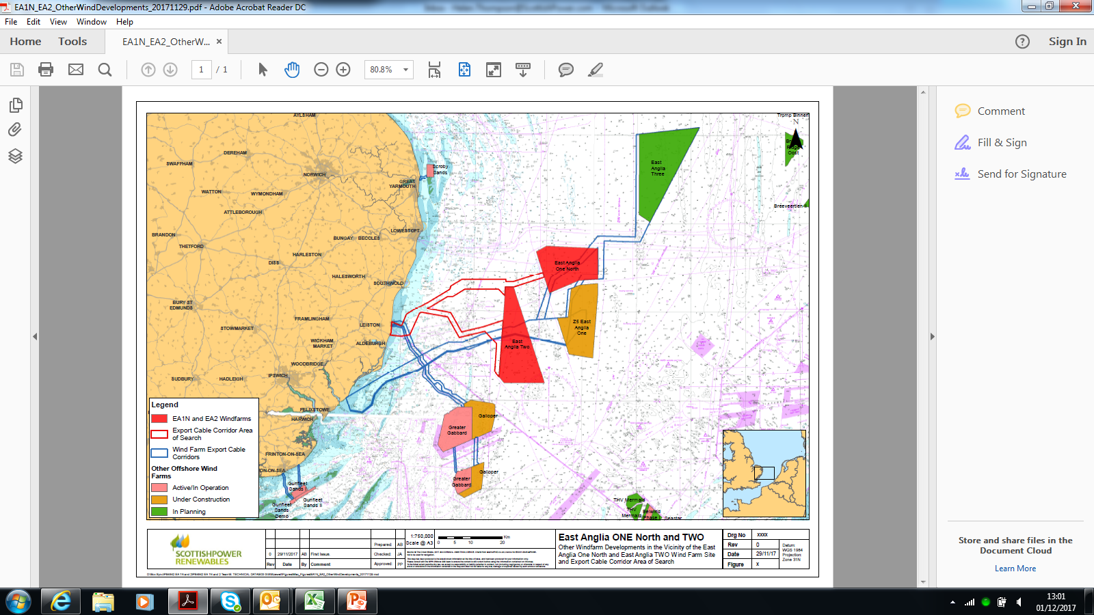

Anglia Three (green) received planning approval in 2017 with construction expected to commence in 2022. Anglia One, Two and One – North are at various stages of planning and construction. These projects all demand major supporting infrastructure such as power cables and grid connections.

Nationally the Government has issued several planning White Papers over the past year and recently proposed changes to the National Planning Policy Framework (consultation ended May 10th).

More locally, the County Council advises and comments on planning applications and Neighbourhood Plans. It is taking an active part in the developing Diss Area NP.

**Education –** Most people will have seen or responded to proposals to change the way Home to School Transport is organised in the County, the main change would limited free transport to the nearest geographic school. The results of public consultation conducted earlier this year are under review, any changes would be proposed and decided upon this summer.

**Council Budget Challenge** –We are now a Business Rates Retention Pilot county with 100% retention being phased in over the next two years. Rates and Community Infrastructure Levy monies are collected by Districts, so the County has to bid for the funds it needs to support growth. These ways of raising funds are fairly new and designed to replace the Revenue Support Grant over time.

The County Council needed to raise Council Tax this year to help pay for needed services, unfortunately the demands on services are increasing mainly for health and social care meaning other areas are squeezed. The graph shows how County funds are allocated:



Our priorities of inclusive growth, health care and well-being, and efficient public services were agreed last June and guide decision making about funds and resources. If you have comments on the priorities or any of this report, please get in touch as I would like to hear your views.

Thank you for your support and participation over the past year.

* Commons Co-ordinator
  + The Marsh is still very wet but should start to dry out with continued warm dry weather.

There are no cattle grazing yet. The area of HK 10 that we topped at the end of summer 2017 is looking good. It will be beneficial to top the area 1079 on the map, (see attached) this year, to achieve similar results, thus maintaining the Marsh within our management rules. Ash and other species are beginning to colonise the area and need to be controlled. Topping would need to take place at the end of the grazing season. The topping carried out last summer was difficult because of the amount of scrub which had established over several years. The next area is not as bad. It would be best to top both areas at the same time to keep them under control.

* Thrandeston Village Hall

Another successful year was had by the Village Hall Committee.

# Fundraising Events

We try and hold a couple of carveries each year. Residents enjoy the good selection of home cooked food and desserts on offer which is felt to be very good value for money, with eat as much as you want. We also have a licensed bar available. The food and wine brings in a good profit.

The annul Hog Roast on the village Green is always a popular event, which brings together local people from surrounding villages with their families and pets. The children and adults enjoy the Vintage Tractor Rally which boosts our funds and brings in different people.

The raffles we do at our events with prizes donated by volunteers also generate an income.

# Volunteer evening

A homemade soup evening was held to thank the volunteers who so kindly gave their time to these events.

# Bookings

We have regular bookings from the Beading Group, Upholstery and Table Tennis. We also have various private functions such as parties, the pony club and elections.

# Future plans

Now that we have had the kitchen completely redecorated, we are looking at ways to improve on energy efficiency. We have to tackle dampness and heat retention. We are looking at various ways of doing this such as, insulated curtains for windows and doors, secondary glazing and ventilation. We may have to replace the front door, with similar door, keeping original fittings. We are planning on having a suspended ceiling and insulation. We are looking at changing the heating and are in the process of getting electrical quotes so this work can be done before redecorating hall.

We have purchased new plain white catering crockery packs which includes, dinner plates, side plates, bowls, cups & saucers for the kitchen.

We are also looking to replace the notice board, which was damaged in the gales. We are finalising paperwork to obtain grant.

We thank our committee and willing volunteers for their dedication. Our aim as always, is to create a village social life that will keep our community and village hall working together.

* Parochial Church Council. St Margaret’s Church, Thrandeston

Janice Mortlock PCC Secretary

The services for the year changed with Family Worship remaining on the first Sunday of the month and on the second Sunday we join with Stuston for their Family Service. This means we only hold one service a month but do have services at Easter, Harvest and Christmas.

At the beginning of the year we installed an alarm to protect the lead on the roof. We were pleased to receive grants, including one from Suffolk Historic Churches Trust, to enable us to proceed with the work.

Mrs Penelope Lucas has worked tirelessly to get the 'Friends of Thrandeston Church' up and running. The main fund-raising events last year were a quiz in May, a strawberry tea in Penny's garden, a fun dog show and a vintage tractor ploughing day. All very enjoyable and successful events.

In September, cyclists took part in the annual Suffolk Historic Churches Cycle Ride and the church was open to receive cyclists taking part in the ride.

The Harvest Festival and Supper was held in September and as a result we were able to donate non-perishable food to the Waveney Foodbank and send a donation to the Christian Missionary Society who are helping refugees in Syria.

The collection from the Carol Service was sent to the East Anglia Children's Hospice.

We continue to be grateful to all who help maintain the church by opening and closing it each day, helping to keep it clean, arranging the flowers and keeping the churchyard tidy. The Visitor's Book in the church frequently records visitor's appreciation that the church is open and there for all to appreciate the peace and calm of the church.

And any other organisations who wish to report.

1. Open Forum – the opportunity for an informal exchange of ideas, views and information

* None.

1. Closing remarks.

* The Chairman thanked everyone for attending the meeting.

Meeting closed at 7:58 p.m.