Minutes of the Meeting of Thrandeston Parish Council held on Tuesday 5th January 2021 by Zoom.

Present:
Councillors Andrew Colchester, Anthony Ronchetti, David Rose and Alison Murton.
District Councillor David Burn.
County Councillor Jessica Fleming
Philip Freeman – Parish Clerk.
No members of the public.

- Apologies for Absence.
- None.

- Chairman’s Opening Remarks
- The Chairman welcomed everyone to the meeting.

- To receive any declarations of pecuniary and non-pecuniary interests from members on any agenda item. To consider any requests for dispensations.
- None.

- Minutes of the previous meeting.
- The minutes of the previous meetings were agreed as a true record.

- Matters arising from the minutes:
Action Points:
- It was agreed that the Clerk would try to contact the landowner about the signs for Footpath 15. Action: The Clerk. The footpath had been damaged when a lorry left the A140 and crashed into the ditch where the path joins the A140.
- Follow up the registration for Quiet Lane nomination. Action: The Clerk. Nothing to report.
- Cheques to be signed. Action: The Clerk. Completed.

- Notification of any urgent business.
- None.

Public Forum.
Report from Councillor Jessica Fleming, Hartismere Division, Suffolk
Jessica.fleming@suffolk.gov.uk Tel: 07714-597980 Twitter: @jesstfleming
From Tier 4 to Tier 5 Alert Level – National Lockdown, refer to the Government website for guidance: https://www.gov.uk/guidance/national-lockdown-stay-at-home

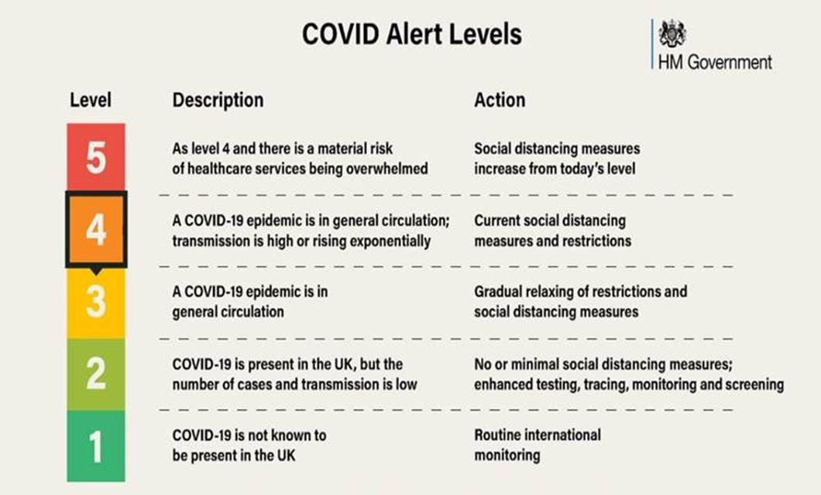
NHS 111 Expanded Helpline Service – reminder to please phone the Helpline before going to A&E.
COVID Support Reminder - The Home But Not Alone freephone 0800 876 6926 is active and staffed from 9am to 5pm Mon. to Fri., as is the Suffolk Advice and Support Service phone 0800 068 3131.
Schools - Special schools and those supporting key workers will remain open during the new lockdown period (estimated to February ½ term), others are to close but please check individual schools for current details:
- https://schoolclosures.suffolk.gov.uk/schools?qorder=time

Primary School application deadline Friday 15 January 2021 for Primary, Infant, Junior or Middle school for September 2021 entry. Applies to children born between 1 Sept. 2016 and 31 Aug. 2017. Go to www.suffolk.gov.uk/admissions, or call 0345 600 0981.
Recycling – The online booking system is operating for recycling centres. Also refer to the Suffolk Recycling Xmas page - www.suffolkrecycling.org.uk/green-christmas

Councillor Fleming agreed to send the Clerk the link to where the Parish Council can request a sign with the village’s name on it at the Mellis Road end of Thrandeston. Action: Councillor Fleming.

Report from Councillor David Burn:
- Deadline for Locality Budget Award has been extended to 12 March 2021 and any applications should be sent to Councillor Burn by 26 February 2021.
- Thrandeston Village Hall has received funding in the past but can apply again.
In response to questions the following points were made:
- The fund is approximately £3,000 and the minimum grant is for £250 and it prioritises any project that helps the community.
- It is possible to claim again even if there has been a grant in the past.
- Mid Suffolk and Babergh District Council’s vehicle fleet will change from form diesel as a fuel to hydro treated vegetable oil. Two tanks will be installed above ground and the Councils are aiming for net zero carbon by 2030. The waste lorry fleet is the largest part of the Councils’ vehicles fleet with one third of emissions from vehicles, but the largest contribution is from leisure centres. The fuel is ‘kinder’ on engines and produces less noxious emissions and any diesel engine can be used. The company providing the fuel is an organisation that commits to not using palm oil.
The Parish Council has received a message from a parishioner about the sign directing people to Marsh Farm:
- The Marsh Farm sign is close to the gate to the Marsh and it is on the grass verge. The owners would need permission for it to be erected there. The Clerk emailed a photograph to Councillor Burn and he will follow it up. Action: Councillor Burn.
- The Council is concerned about an increase in the number of vehicles coming through the village when there are events at the venue. The sign does not affect access to the Marsh. People using sat navs will follow the directions given to arrive at the Farm.
- The business is up and running and there may have been one event before the first lockdown.
- There is nothing to stop people approaching Marsh Farm from the A140, but the owner of the business could be asked to encourage them to use the road from the A143.

- Correspondence received.

- Various documents from SALC.
- Town and Parish Council Newsletter.
- Various emails from the Highways Department of Suffolk County Council.
- Constables’ Country
- Suffolk View.
- Cranswick Foods Update.
- COVID-19
- Email about the sign directing visitors to Marsh Farm. See above.

- Report from Committees:
  - Village Hall Committee
- Building Regulations at MSDC has told the Village Hall Committee that they need a timber frame for the alterations to the ceiling, but they have been advised by the builder/suspending ceiling installer they can use the current ceiling timbers.
- The suspended ceiling is to help with sound levels and to allow ceiling insulation to be installed. The advantage of ceiling tiles is they would need less maintenance and the ceiling will be above the level of the windows.
- There is one problem as there is no means of getting into the roof space from the Village Hall part of the building.
- Councillor Burn asked the Charman to copy correspondence to the Building Regulations Department to him.
- The Village Hall is not listed.
- The Council thanked the Chairman for all the work she has done on the improvements.

- The Common
  - Report from the Commons Co-ordinator.
- The cattle were removed from the Marsh on 4th November 2020.
- It has been a very wet winter, but the cattle have not caused any poaching.
- The water level has subsided, as the ditches had been cleared on Mr Ling’s side of the Marsh.
- There will be no capital works on the Marsh before the end of the current agreement. The funding from the RPA should continue under the new arrangements following Brexit as it is linked to conservation.

- COVID-19 measures and impact on our village events.
- Nothing to report.

- Highway matters:
  - Quiet Lanes
  - Nothing to report.

- Finances and financial report.
  - Balances on Accounts 27th November 2020.
    - Current account: £8,318.55
- Councillors noted the account balances.
  - Financial report and bank reconciliation.
    - Detailed accounts had been given to Councillors, which recorded all items of income and expenditure, and compared them to the budget. The spreadsheet also showed both as a percentage of the budget.
    - The accounts were to the date of this meeting and included a bank reconciliation.
    - There were no questions from Councillors.
  - Budget and precept
- The proposed budget had been sent to Councillors and following a discussion it was agreed; and the precept will be set at £2,500. Proposed by Councillor Murton and seconded by Councillor Rose.
  - To authorise cheques for signature:
N.B. Cheque signatories to initial cheque stub and invoice.
Payee | Details | Cheque Number | Amount | Power
P Freeman | Clerk’s Pay and Expenses including payment below. | 100638 | £308.05 | LGA 1972 S112
HMRC | PAYE | 100639 | £62.30 | LGA 1972 S112
One Suffolk | Website Hosting Subscription replacement cheque paid by the Clerk from his business account. |  | £60.00 | LGA 1972 s111

- It was unanimously agreed to pay the invoices listed above, proposed by Councillor Murton and seconded by Councillor Colchester. The Clerk will take the cheques to Councillors Murton and Ronchetti to be signed.
  - Requests for financial support: none.
  - Receipts: RPA - £1,621.05.

- Casual Vacancy
- Following a discussion, it was agreed to place notices on the notice boards in the village to advertise the vacancy.

- Planning:
  - Applications:
    - Statutory consultation on proposals for Sunnica Energy Farm.
    - Application for Prior Approval - Agricultural to Dwelling - DC/20/05757.
Proposal: An application to determine if prior approval is required for a proposed: Change of Use of Agricultural Buildings to Dwelling houses (Class C3), and for building operations reasonably necessary for the conversion. The Town and Country Planning (General Permitted Development) (England) Order 2015 (as amended) Schedule 2, Part 3,
Class Q - Conversion for form 1No dwelling.
Location: Rectory Farm, Great Green, Thrandeston, Diss Suffolk IP21 4BN.
- Following a discussion, it was agreed to make no comment on either application.
  - Applications – no decisions to date:
    - Various Applications for Progress Power Station listed previously.
    - Application for Advertisement Consent - DC/20/03957
Proposal: Application for Advertisement Consent - Erection of 2No signs each consisting of 14 plate signs advertising Roy Humphrey Group businesses within the Eye airfield industrial complex.
Location: Roy Humphrey Group, Ipswich Road, Eye, Suffolk
    - Application DC/19/00667
Proposal: Full Planning Application - direction of 2NO. B8 storage buildings and link extension between buildings 6 and 7.
Location: land on Eye Airfield, Ipswich Road, Eye.
  - Planning decisions:
    - Approved: None.
    - Refused: None.
    - Discharge of Conditions: None.
    - Withdrawn: None.

- AOB - Any items raised earlier but not for an extended discussion or decisions and items for inclusion at the meeting on Tuesday 2nd March 2021.
- The work by tree surgeons from UK Network Power has been postponed to 26 January 2021 and it may require the power to be turned off.
- Councillor Colchester will carry out work on the hedges near the footpath which starts at the Mellis Road.
- If there is any fly tipping within Thrandeston it should be reported to the Clerk, who will report it.

Meeting closed at 8:37 p.m.

