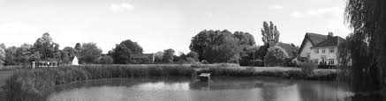

Thrandeston

Annual Parish Meeting

7.00 pm, Wednesday 4th May 2022 at Mellis Memorial Hall

Please note change of venue for this meeting it will be at Mellis Memorial Hall.

AGENDA

- Apologies for absence

- Chairman’s opening remarks.

- Reports
To receive reports from:
- Thrandeston Parish Council – Councillor Murton
- Mid Suffolk District Council – Councillor David Burn
- Suffolk County Council – Councillor Jessica Fleming
- Commons Co-ordinator – Councillor A Colchester
- Thrandeston Village Hall - Councillor Murton
- Parochial Church Council. St Margaret’s Church, Thrandeston – Mrs J Mortlock

And any other organisations who wish to report.

- Open Forum – the opportunity for an informal exchange of ideas, views and information

- Closing remarks.

